LaShonda Renea Maxfield, J.D., M.H.A
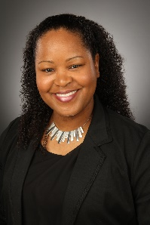
LaShonda Renea earned her Bachelor of Arts degree in Political Science with a concentration in Public Administration from Fayetteville State University in North Carolina. She earned her Juris Doctorate degree from Loyola University in New Orleans and is currently licensed to practice law in Texas. She recently received her Masters of Healthcare Administration from the University of North Carolina at Chapel Hill.
LaShonda Renea has worked with various non-profit and small businesses as a consultant. Although her tasks were generally law related, she found herself having to react to varying business and personal issues that she felt could have been easily preventable. Her focus quickly evolved from consulting to counseling individuals and small groups on the importance of taking a proactive approach to their personal and business affairs by proper planning. It was through these experiences that birthed the concept of contingency planning that emphasizes taking a proactive, rather than reactive approach to managing both life and business matters.
Most people struggle with organization and planning. LaShonda Renea helps people create a plan (blueprint) for their lives to minimize stress and anxiety to increase clarity and confidence. She is a planning strategist and contingency planning expert. LaShonda Renea is the owner of a Personal Development Company (Maxfield Enterprises, LLC) that provides various services including Keynote speeches, Workshops, Training and Coaching. She specializes in working with Young Adults under age 30.
LaShonda Renea has been a speaker and panelist at the University at North Carolina (Charlotte) for their annual women’s leadership conference. She has also been a speaker at the University of North Carolina at Chapel Hill’s School of Public Health for their Master degree program students.
LaShonda Renea is both the creator and author of the “Legal First Aid” series. She is also the author of the “Sudden Cardiac Arrest Survivor’s Planner” and the “Sermon Notebook.”
www.LaShondaRenea.com

